**Report: “Promoting Peace in Gaza**

**The role of Pakistan and Muslim Nations in achieving a cease fire.”**

**Event Date: 16 May,2024**

**Venue: SZABIST Campus H-8/4 Islamabad.**

**Introduction:**

Muslim countries are always being a soft victim in the hands of foreign power. The formation of OIC although criticized for its working even then it has been seen as a threat by the West. On February 22,1974 the OIC Summit in Lahore was seen as a power show as a threat and since then we are hearing news of the murder of the heads who attended this meeting. Bhutto, Mujib, Shah Faisal, Sadat, Arafat, Gaddafi; all died unnatural deaths in one way or other. Keeping in view the current situation and instability created in Muslim Countries by foreign powers in the name of insurgency and to create stability it is merely an eye wash. Shaheed Bhutto Foundation CEO Mr Asif Khan keeping the legacy of Bhutto again try to bring Muslim countries in one plat form where his excellence Mr. Ahmed Rabbaie consulate of Palestine was the chief guest and consulate of Iran joined the forum too.

**Significance:**

This forum marked a historical perspective where audience in large number especially students joined too creating a same impact as was created in Lahore Summit 1974. This seminar strengthens the concept of Muslim Ummah and made the youth realize the importance of Unity. It also sends a clear message that Muslim Community is just like a body if one of its parts is in pain all other parts stop smooth functioning as well.

The seminar was carried forward with speakers addressing the Gaza Issue.

**CEO Mr. Asif Khan:**

Warm welcome everyone. Ambassador of Palestine belonging to the land of bravest and most gallant people of the globe, who are steadfastly resisting American and Western atrocities towards them. Our organization was formed by Shaheed Benazir. In 2004 in Dubai with the main aim to promote human rights and democracy. Our mandate is to hold seminars, workshops and discussions to enlighten the minds of people. We all have been reading newspaper and this genocide is going for six months consistently, and 40000 Palestinians are killed with people residing in shelters, since residential areas have been destroyed. Few weeks before many countries in UN has approved Palestine membership but nine nations disapproved it in which America is one of them. Even those countries which we have no ties they are with Palestine. I welcome consulate of Iran who is here to show solidarity with us.

**Farhatullah Babar:**

I welcome Mr. Ambassador to this auspicious Institution built in the name of Bhutto who was martyred as well. Bhutto regime has always helped Arabs against Israel. And it is true it is the job of government to do the same. It is the role of the Government and civil society to work for peace promotion. The massacre includes large number of children and women who has nothing to do with the war. We have seen enough and now it's high time to end this genocide. France when occupied Algeria it was genocide and again, we are caught in the same situation. The retreat will be worse than war. It is advised to raise the voice combined by all the nations to stop the war at once and go for peace. The endurance of Palestinians has taught many lessons to the world, but I have a hope and a dream if not me, but my children and grandchildren will live to see from Jordan to Mediterranean sea as a free land.

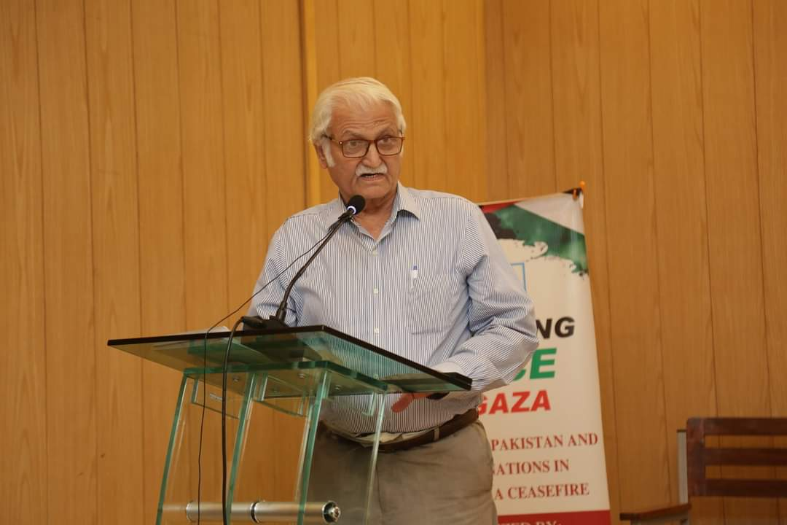

**Miss Humaira Tayyab:**

Iam deeply thankful to the organization who has bring this topic and asked me to shed the light on this issue. She quoted Surah Buruj having similarity with the Palestinian situation. She explained that in this surah Muslims were killed by burning them and non-muslims were watching it as an entertainment. Same they are the victims, and we all are the bystanders. Nothing is done. One of the genocides even after 222 days everyone is watching live and doing nothing. Then what is the difference between us and Ashab ogdoad. I have been raising my voice since November 2023. Funding is not the issue but there is a huge blockade of how anyone can help. It is high time civil societies to raise voice as one to go for cease fire.

**His Excellence Ahmed Rabaie:**

I still remember the efforts of Bhutto in 1974 OIC Conference Lahore. I remember when pilot of Pakistan destroyed Israel plane in 1963 and helped us fight in 1982 against occupation of Israel. I I would like to thank Pakistan and its inhabitants who are supporting us and raising our morale in this tough time. And I prayed by heart than one day we all will be praying in Masjid-e-Aqsa. He remembered incident of 1974 when the same attack was launched and since than Palestine is under evil eyes of Israel. Our 500 Palestinian villages have been destroyed since 1948 and this time the attack is highly breach of human rights. 90 % hospitals have been destroyed including 208 mosques. We are not able to defend all alone, but we want support by our muslims brothers. Finally, I would like to thank everyone for giving us a platform to have catharsis.

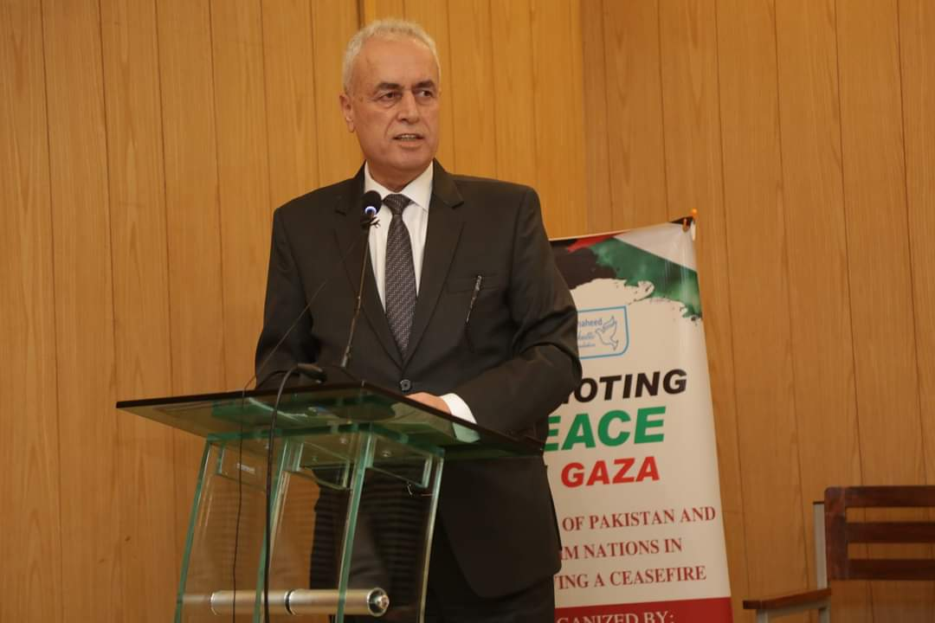

The seminar ends by giving shield on behalf of Shaheed Bhutto Foundation CEO and Mr. Farhatullah Babar to Palestinian Ambassador.

